Assume Tables:
SAVINGS_ACCOUNT: AccountID, CustomerID, Balance
EMPLOYEES: EmployeeID, EmployeeName, DepartmentID, Salary
ACCOUNTS: AccountID, CustomerID, Balance

Scenario 1:
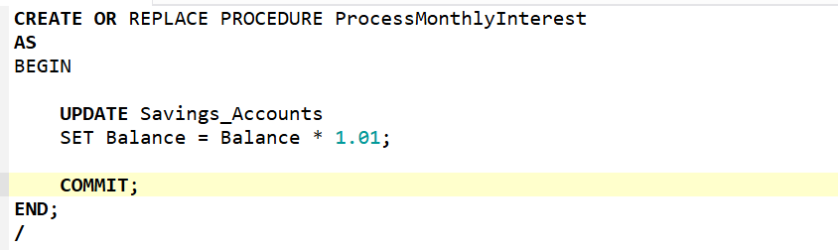

Scenario 2:
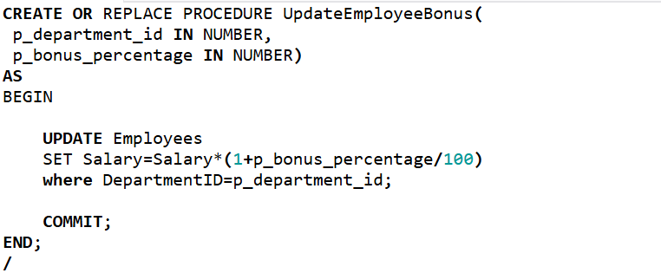
Scenario 3:
